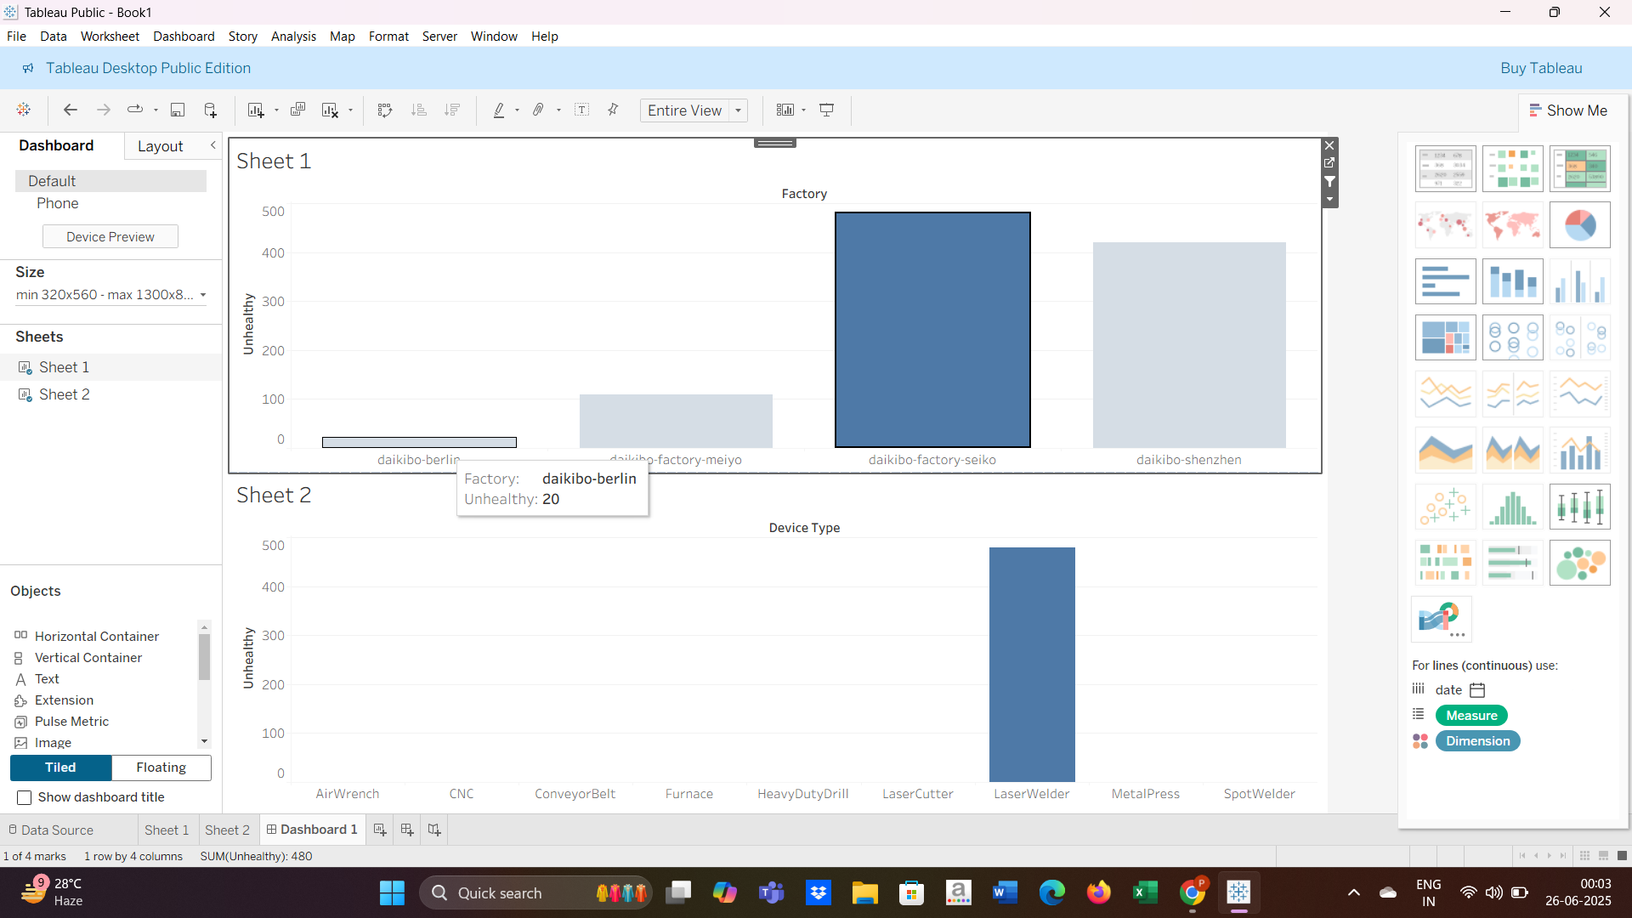

1. In which location did machines break the most?

The machines in the Seiko branch of daikibo breaks the most. (Unhealthy : 480)

1. What are the machines that broke most often in that location?

Laser Welder is the machine that breaks the most. (Unhealthy : 480)

**Deloitte Australia Data Analytics Job Simulation on Forage - June 2025**

* Completed a Deloitte job simulation involving data analysis and forensic technology
* Created a data dashboard using Tableau
* Used Excel to classify data and draw business conclusions

**“Why are you interested in this role?”**

I recently participated in Deloitte's job simulation on the Forage platform, and it was incredibly useful to understand what it might be like to be part of the team at Deloitte.

I was able to analyse data and create a dashboard. I practised using Tableau and Excel and built my data analysis skills in a real-world context.

Doing this program confirmed that I really enjoy working on technology problems for clients and I'm excited to apply these skills on a team at a company like Deloitte.